Fundamentals of Programming

Lab Manual # 04

Course Instructor: Dr. Talha

Lab Instructor: Muhammad Affan

**Name:** M. Moeez Zafar

**CMS ID:** 456063

Date:

26-10-2023

Home Task:

1)

Write a C++ Program that prints the numbers from 1 to 150 except the multiples of 10.

#include <iostream>

using namespace std;

int main()

{

for(int i=1;i<151;i++)

{

if(i%10!=0)

{

cout<<i;

}

}

Return 0;

}

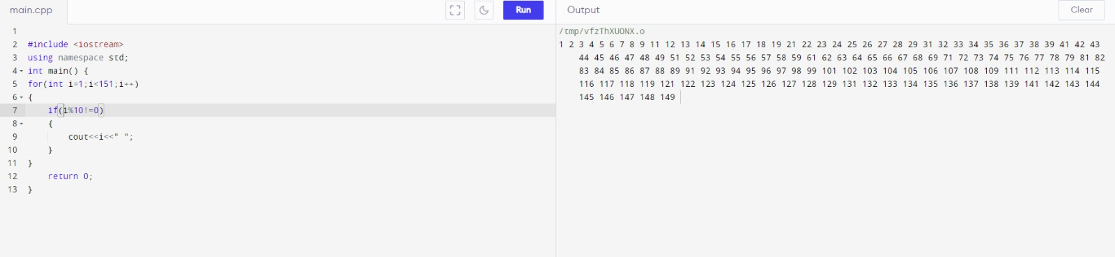

2)

Write a C++ program to find the sum of digits of a number.

#include <iostream>

using namespace std;

int main()

{

cout<<”please enter your number”<<endl;

int num=0;

cin>>num;

int quo=0;

int accumulate=0:

int i=0;

while(i<1)

{

if(num>10)

{

quo=num%10;

num=num/10;

accumulate=accumulate+quo;

}

else if(num<10)

{

i=i+2;

accumulate=accumulate+num;

}

}

cout<<”the sum of the digits is”<<accumulate<<endl;

Return 0;

}

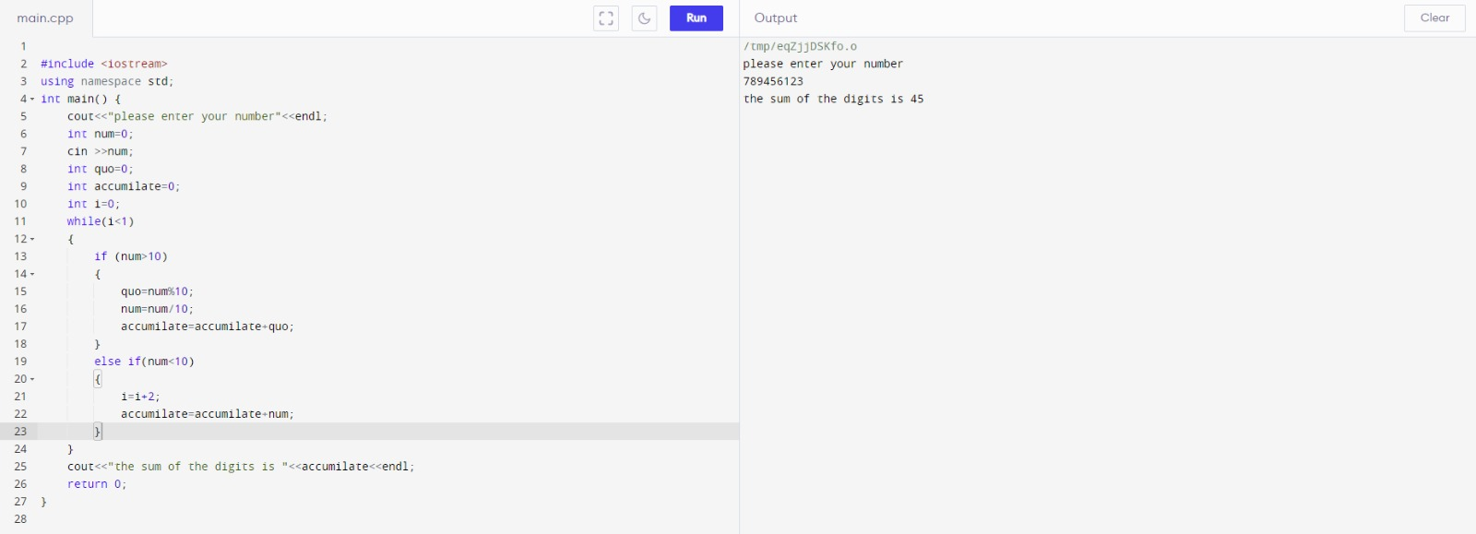

3)

Write a C++ program to check whether a number is prime or not

#include <iostream>

using namespace std;

int main()

{

int number;

int factors=1;

cout<<"enter your number"<<endl;

cin>> number;

for(int i=1;i<number;i++)

{

if(number%i==0)

{

factors++;

}

}

if(factors<=2)

{

cout<<"The number is Prime";

}

else

{

cout<<"The number is not prime";

}

}

